**Assignment -3**

Python Programming

|  |  |
| --- | --- |
| Assignment Date | 15 October 2022 |
| Student Name | Mr P Sathiyananth |
| Student Roll Number | 621319104051 |
| Maximum Marks | 2 Marks |

**Question-1:**

Create a Bucket in IBM object storage.

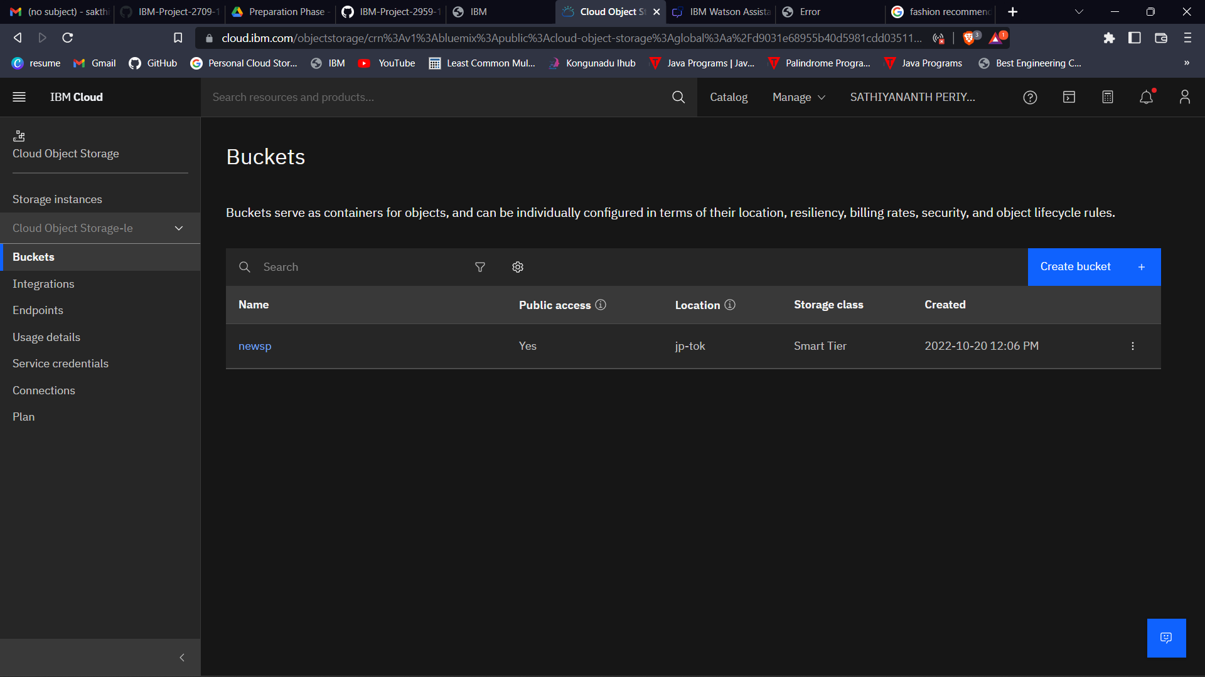

**Question-2:**

Upload an 5 images to ibm object storage and make it public. write html code to displaying all the 5 images.

**Question-3:**

Upload a css page to the object storage and use the same page in your HTML code.

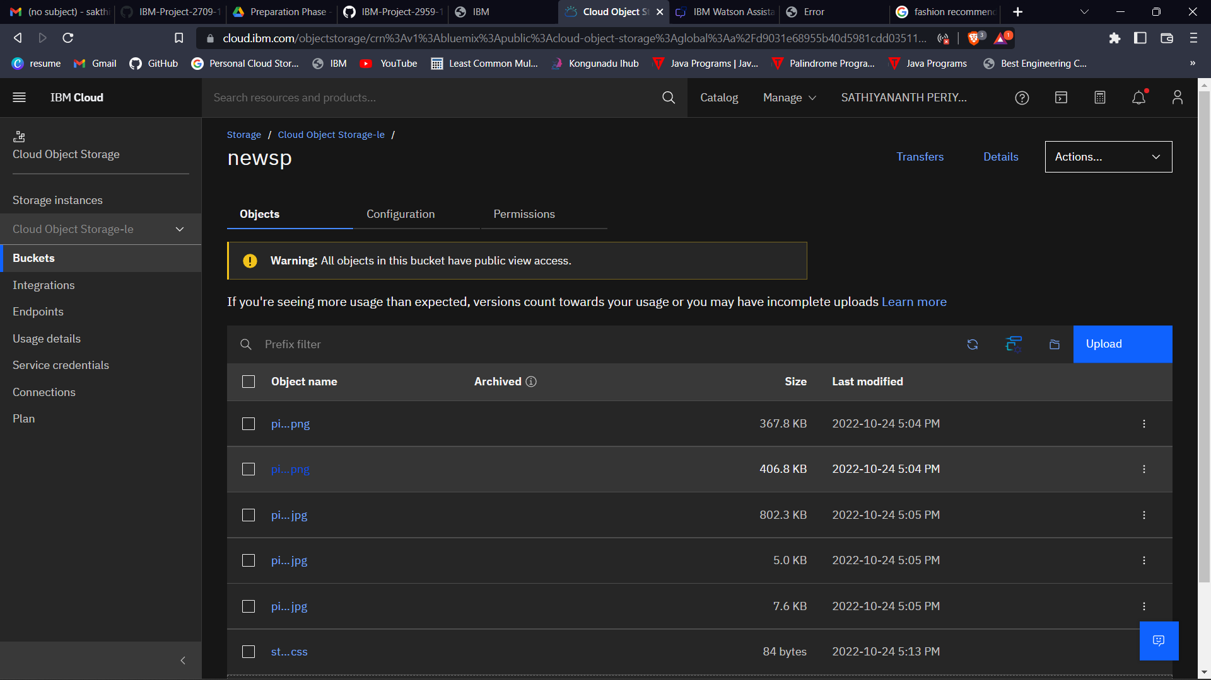

**Code:**

**Home.html**

<html>

<head>

<title>Assignment 3</title>

<link rel="stylesheet"

href="https://newsp.s3.jp-tok.cloud-object-storage.appdomain.cloud/style.css">

<script>

window.watsonAssistantChatOptions = {

integrationID: "077aae19-3307-4a90-90b3-9dc9fd7916fd", // The ID of this integration.

region: "au-syd", // The region your integration is hosted in.

serviceInstanceID: "3f42b0bd-fe7d-49ed-b006-c88f5472a62f", // The ID of your service instance.

onLoad: function(instance) { instance.render(); }

};

setTimeout(function(){

const t=document.createElement('script');

t.src="https://web-chat.global.assistant.watson.appdomain.cloud/versions/" + (window.watsonAssistantChatOptions.clientVersion || 'latest') + "/WatsonAssistantChatEntry.js";

document.head.appendChild(t);

});

</script>

</head>

<body>

<center>

<h1>Fashion dress images</h1><br><br>

<img src="https://newsp.s3.jp-tok.cloud-object-storage.appdomain.cloud/pic%201.png" width="300" height="300"><br><br>

<img src="https://newsp.s3.jp-tok.cloud-object-storage.appdomain.cloud/pic%202.png" width="300" height="300"><br><br>

<img src="https://newsp.s3.jp-tok.cloud-object-storage.appdomain.cloud/pic%203.jpg" width="300" height="300"><br><br>

<img src="https://newsp.s3.jp-tok.cloud-object-storage.appdomain.cloud/pic%204.jpg" width="300" height="300"><br><br>

<img src="https://newsp.s3.jp-tok.cloud-object-storage.appdomain.cloud/pic%205.jpg" width="300" height="300"><br><br>

</center>

</body>

</html>

**Question-4:**

**Design a chatbot using IBM Watson assistant for hospital. Ex: User comes with query to know the branches for that hospital in your city. Submit the web URL of that chat bot as a assignment.**

**Question-5:**

**Create Watson assistant service with 10 steps and use 3 conditions in it. Load that script in HTML page.**

**Output:**



